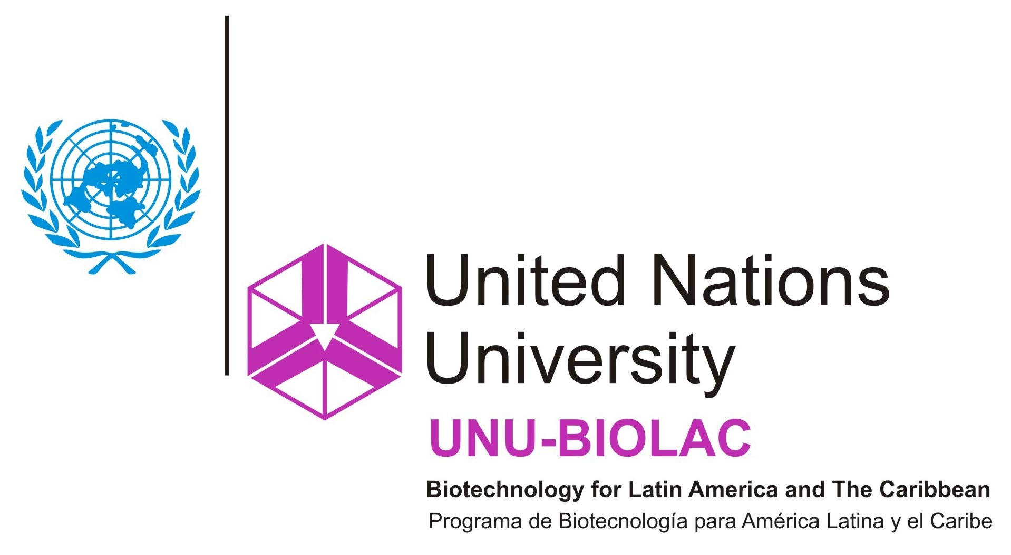

ICGEB course:

First international workshop on the food and environmental safety assessment of genetically modified animals.
5-9 September 2011, Buenos Aires City, Argentina.

Organized by the following Institutions and sponsors:
- Argentine Ministry of Agriculture, Livestock and Fisheries, (SAGyP, Biotechnology Directorate).
- International Centre for Genetic Engineering and Biotechnology (ICGEB).
- United Nations University Biotechnology Programme for Latin America and the Caribbean (UNU-BIOLAC).
- International Life Sciences Institute (ILSI Argentina).

Rationale:

Genetically modified animals intended for commercial production are approaching the market. As a result, international organizations and the national authorities of a number of countries are developing frameworks for the food and environmental safety assessment of genetically modified animals. Currently, there is a need for exchanges between regulators working for regulatory agencies, professionals working on animal biotechnology and experts in the field of biosafety research.

This Workshop will review the emerging elements of regulatory frameworks for the food and environmental safety assessment of genetically modified animals and related technologies. It is intended primarily for professionals working in regulatory agencies, researchers working on animal biotechnology and experts in the field of biosafety research. The main objectives of the workshop are disseminating information, enhancing cooperation and providing capacity building.

Programme:

September 5, 2011: Introduction to genetic modification of animals

Morning:

- Introduction.

10:00 Welcome remarks
Dr. Lorenzo Basso (Secretary of Agriculture, Livestock, and Fisheries, ARG)
Dr. Lino Baranao (Minister of Science, Technology and Innovation, ARG).

10:15 Remarks by co organizers, representing sponsor/supporting Institutions - Introduction to course contents and exercises
Dr. Moises Burachik (Biotechnology Directorate, SAGyP, ARG).
Dr. Giuliano Degrassi (ICGEB)
Dr. Jose Luis Ramirez (UNU-BIOLAC)
Dr. Juan Carlos Lopez Mussi (ILSI Argentina)
Prof. Martin Lema (Biotechnology Directorate, SAGyP, ARG).

- State of the art in the genetic modification of animals and related technologies.

11:00 Technologies for obtaining genetically modified (GM) animals and animal cloning technologies
Dr. Lino Baranao (Minister of Science, Technology and Innovation, ARG).
Dr. Daniel Salamone (University of Buenos Aires, ARG).

12:00 Impact of Biotechnology on Livestock Production Competitiveness.
Mg. Alejandro Silva (Head of SAGyP Cabinet).

12:30 Lunch Break.

Evening:

- Survey on developing products.

13:30 Expression of pharmaceuticals in bovine milk
Dr. Andrés Bercovich (Biosidus, ARG).

14:10 Enviropig
Dr. Cecil Forsberg (Guelph University, CAN).

15:10 Fish with enhanced growth rate
Dr. John Buchanan (Aquabounty Technologies, USA)

16:00 Sterile insects
Dr. Camila Beech (Oxitec Limited, UK)

16:40 transgenic goats expressing human lysozyme
Dr. James D. Murray (UC Davis, USA)

17:20 Other products in the pipeline
Dr. David Edwards – (Biotechnology Industry Organization)

September 6, 2011: Environmental biosafety assessment

- International Guidance and National Experiences.

09:00 Applicability of Annex III of the Cartagena Biosafety Protocol
Eng. Perla Godoy (Biotechnology Director, SAGyP, ARG)

09:30 Tools for biosafety assessments and regulatory decision making
Dr. Giuliano Degrassi / Dr. Marianela Araya (ICGEB, IT).

10:00 The environmental safety assessment of hGH-expressing cattle
Moises Burachik (Biotechnology Directorate, SAGyP, ARG).

10:45 OECD consensus document on the biology of Atlantic salmon
Bertrand Dagallier, OECD Biosafety Programme.

11:30 The Canadian regulatory experience on GM Animals
Dr. Arash Shahsavarani (Environment Canada, CAN)

12:15 The Cartagena Protocol Roadmap and the EFSA project on the assessment of GM mosquitoes.
Gaugitsch Helmut, Federal Environment Agency (Austria).

13:00 Lunch Break (lunch on site)

Evening

- Focus on critical issues

14:00 Environmental risk assessment of GM fish
Dr. William Muir (Purdue University)

15:00 Confinement methodologies
F. Zelaschi (Biotechnology Directorate, ARG)

16:00 To be defined
To be defined

17:00 Comparative fitness
Dr. W Vandersteen, (Fisheries and Oceans Canada)

September 7, 2011: Food safety assessment

Morning

- International Guidance and National Experiences.

09:00 FAO/WHO work on GM animals: expert consultations for provision of scientific advice
Dr. Masami Takeuchi (FAO)

09:45 Codex guidance on the food safety assessment of r-DNA animals
Dr. Lisa Kelly (Food Standards, AU)

10:45 Experience on the food safety assessment of GM animals.
Dr. Larisa Rudenko (FDA, USA).

12:00 EFSA safety assessment strategy for foods derived from GM animals.
Dr. Harry Kuiper (Chair of the ad hoc EFSA Working Group).

13:00 Lunch Break (lunch on site)

Evening

- Food safety assessment methodologies: From past experience in plants to prospective application in animal products

14:00 Toxicity and bioactivity assessment
Eng. Juan Carlos Batista (SENASA, ARG)

14:45 Assessment of nutritional content
Dr. Marilia Nutti (Embrapa, BR)

15:30 Allergenicity assessment
Dr. Clara Rubinstein (ILSI, AR)

16:15 Other issues: antibiotic marker genes, food storage and processing, intended nutritional modification, accumulation of xenobiotics or microorganisms, use of laboratory animals.
Dr. Bruce Chassy (ILSI, US).

17:00 Influence of breeding environment on the variability of animal food nutritional parameters
Agr. Eng. Lorenzo Basso (ARG)

September 8, 2011: Transgenic Animals vs Animal clones

IMPORTANT NOTE: Due to budgetary and management limitations, the field visits will be limited to 30 persons. Priority will be given to speakers and participants receiving fellowships from ICGEB and UNU-BIOLAC.

Morning

- Field visit to a farm of transgenic cattle, including:
  - Visit to delivery area, breeding and other facilities
  - Revision of biosafety measures in place
  - Inspection of the animals and their health status
  - Explanation by local technicians regarding practical experiences, technologies used, breeding practices, etc.

Evening

- Field visit to a farm breeding cloned livestock.

- Presentations on Biosafety assessment and regulation of (not transgenic) animal clones

16:00 The FDA experience in the food safety assessment of animal clones
Dr. Larisa Rudenko (FDA, USA).

September 9, 2011: Conclusion

Morning

- Socioeconomic issues in stake

09:00 Ethical Analysis
Kate Millar (University of Nottingham, UK).

10:00 Public perception and participation
Dr. Lynn Frewer (EU Pegasus Project on Public Perception of
Genetically modified Animals -Science, Utility and Society)

11:00 Potential impact on developing countries: issues regarding intellectual property and genetic resources
TBD

12:00 TBD

13:00 Lunch Break (lunch on site)

Evening

- Prospective debate and report

14:00 Group debate on guidance gaps, capacity building needs, and networking strategies, for the development of regulatory activities in the area.
Subgroups:
      - Food safety assessment
      - Environmental assessment
      - Handling of socioeconomic issues

16:00 Report of subgroup conclusions and drafting of a final report

18:00 Adjourn

For participating in the workshop (please visit http://www.agrobiotecnologia.gov.ar/gmanimal2011/

A selection process will be applied on the applications received, taking into account the purpose and target of the workshop, as well as the capacity of the facilities to be used. The workshop itself is free of charge. In order to apply for participating in the workshop, please send your participation form by email to gmanimal2011@minagri.gob.ar
Note: the timeframe for applying to ICGEB or UNU-BIOLAC fellowships is closed. Applications of participants willing to cover their own personal (travel, accommodation, meals, etc.) costs will be received up to the week before the event.

